Programming Languages Research Report

Course: CST 8002-040 Programming Languages Research Proj.
Assignment: Practical Assessment 01
Instructor: Tyler DeLay
Student Name: Qinyu Luo
Student ID: 041137796
Due Date: 09/06
Submitted: September 6

Evidence of Learning
Variables
Explanation: Variables store data in memory for later use. This project uses variables to store arrays, objects, and primitive types.
// From business/DataManager.js (lines 15-18)
constructor() {
this.records = []; // Array variable
this.fileHandler = new FileHandler(); // Object variable
this.datasetPath = 'data/dataset.csv'; // String variable
}

Methods/Functions
Explanation: Methods encapsulate reusable code logic. This method creates a new record and adds it to the data structure.
// From business/DataManager.js (lines 48-56)
createRecord(data) {
try {
const newRecord = new Record(
data.siteIdentification,
parseInt(data.year),
parseInt(data.transect),
parseInt(data.quadrat),
data.speciesCommonName,
parseInt(data.count)
);
this.records.push(newRecord);
return true;
} catch (error) {
return false;
}
}

Loop Structure
Explanation: Loops iterate through collections. The forEach loop displays all records and shows the author's name every 10 records.
// From presentation/UserInterface.js (lines 95-104)
displayAllRecords() {
records.forEach((record, index) => {
console.log(`[${index}] ${record.toString()}`);

if ((index + 1) % 10 === 0) {
console.log(`\n--- Program by ${this.yourFullName} ---`);
}
});
}

Decision Structure
Explanation: Conditional statements control program flow. The if statement validates the index, and switch handles menu choices.
// From business/DataManager.js (lines 78-83)
getRecord(index) {
if (index >= 0 && index < this.records.length) {
return this.records[index];
}
return null;
}

// From presentation/UserInterface.js (lines 215-225)
switch (choice) {
case '1':
this.dataManager.reloadData();
break;
case '2':
this.dataManager.saveData();
break;
default:
console.log('Invalid choice');
}

File I/O - Reading from Dataset
Explanation: The program reads CSV data from disk, parses it, and converts it into Record objects.
// From persistence/FileHandler.js (lines 20-35)
readRecordsFromFile(filePath, maxRecords = 100) {
const fileContent = fs.readFileSync(filePath, 'utf-8');

const records = parse(fileContent, {
columns: true,
skip_empty_lines: true,
from_line: 2
});

const limitedRecords = records.slice(0, maxRecords);

return limitedRecords.map(row => {
return new Record(
row['Site identification'],
parseFloat(row['Year']),
parseFloat(row['Transect']),
parseFloat(row['Quadrat']),
row['Species Common Name'],
parseInt(row['Count'])
);
});
}

File I/O - Writing with UUID Filename
Explanation: Data is saved to a new CSV file with a UUID-generated filename to ensure uniqueness.
// From persistence/FileHandler.js (lines 60-75)
saveRecordsToFile(records, outputDir = 'data') {
// Generate UUID filename
const filename = `${uuidv4()}.csv`;
const filePath = `${outputDir}/${filename}`;

// Create CSV content
let csvContent = 'Site identification,Year,Transect,Quadrat,Species Common Name,Count\n';

records.forEach(record => {
csvContent += record.toCSV() + '\n';
});

// Write to file
fs.writeFileSync(filePath, csvContent, 'utf-8');

return filePath;
}

Exception Handling
Explanation: Try-catch blocks handle errors gracefully, preventing the program from crashing when files are missing or data is invalid.
// From persistence/FileHandler.js (lines 18-28)
readRecordsFromFile(filePath, maxRecords = 100) {
try {
const fileContent = fs.readFileSync(filePath, 'utf-8');
// ... parsing code
return recordObjects;
} catch (error) {
if (error.code === 'ENOENT') {
throw new Error(`File not found: ${filePath}`);
}
throw new Error(`Error reading file: ${error.message}`);
}
}

Use of API Library
Explanation: The project uses external libraries: uuid for unique file naming, csv-parse for parsing CSV files, fs for file operations, and readline for user input.
// From persistence/FileHandler.js (lines 9-11)
import fs from 'fs';
import { parse } from 'csv-parse/sync';
import { v4 as uuidv4 } from 'uuid';

// Usage examples:
const filename = `${uuidv4()}.csv`; // UUID library
const records = parse(fileContent, {...}); // CSV-Parse library
fs.readFileSync(filePath, 'utf-8'); // File System library

Array (Data Structure)
Explanation: Arrays store collections of Record objects. The program uses array methods like push, splice, and index access to manage data.
// From business/DataManager.js
constructor() {
this.records = []; // Initialize array
}

createRecord(data) {
this.records.push(newRecord); // Add to array
}

getRecord(index) {
return this.records[index]; // Access by index
}

deleteRecord(index) {
this.records.splice(index, 1); // Remove from array
}

getRecordCount() {
return this.records.length; // Get array size
}

Unit Testing
Explanation: Automated tests verify that program functions work correctly. Jest framework is used with assertions to check expected outcomes.
// From tests/DataManager.test.js (lines 9-27)
import DataManager from '../business/DataManager.js';

describe('DataManager CRUD Operations', () => {
let dataManager;

beforeEach(() => {
dataManager = new DataManager();
});

test('should create a new record successfully', () => {
const recordData = {
siteIdentification: 'TEST001',
year: 2024,
speciesCommonName: 'Test Species',
count: 10
};

const result = dataManager.createRecord(recordData);

expect(result).toBe(true);
expect(dataManager.getRecordCount()).toBe(1);
});
});

Program Architecture

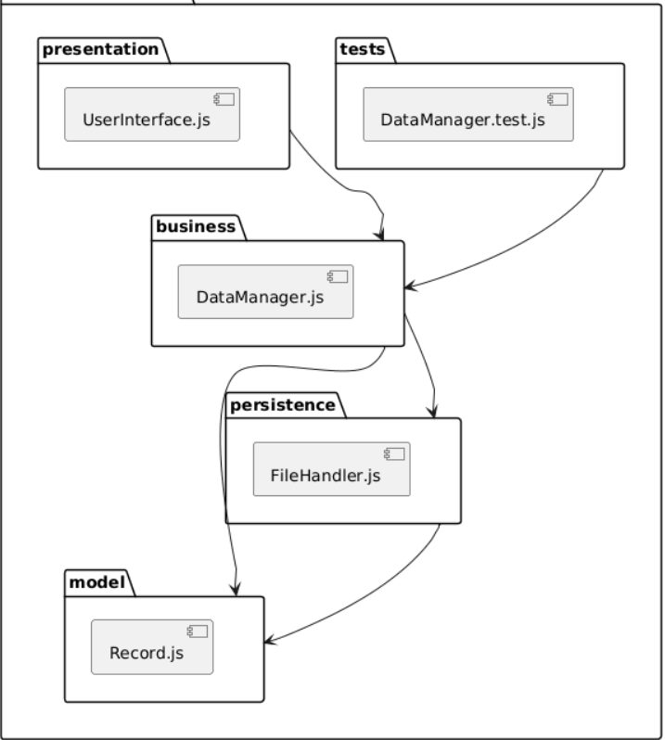
This diagram illustrates the project's four-layer architecture with folders for model, persistence, business, and presentation layers.
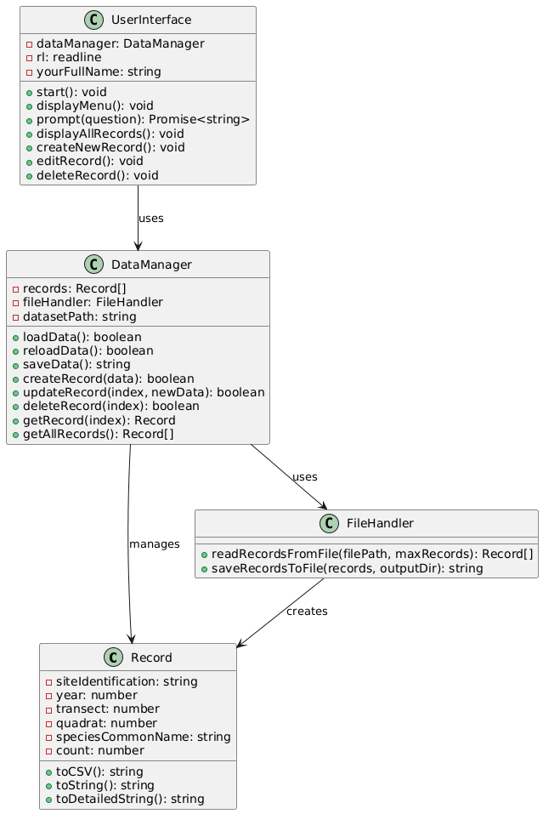
This diagram shows the four main classes (Record, FileHandler, DataManager, UserInterface) and their relationships through composition and dependency.

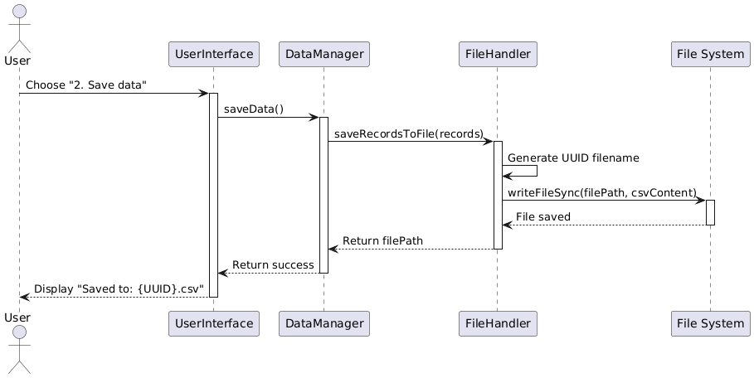
This diagram demonstrates the interaction flow between layers when the user saves data to a file with UUID filename generation.

Program Demonstration via Screen Shots
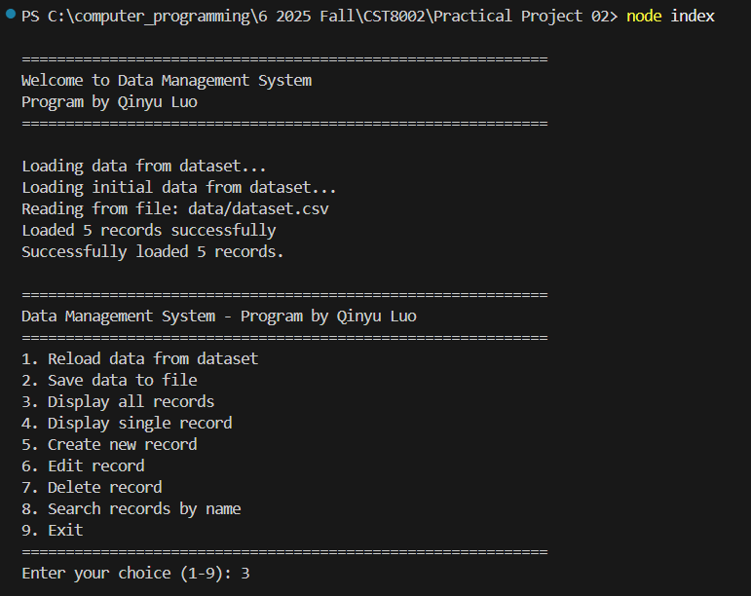
The program successfully starts, displays my full name, and loads 5 records from the dataset file.
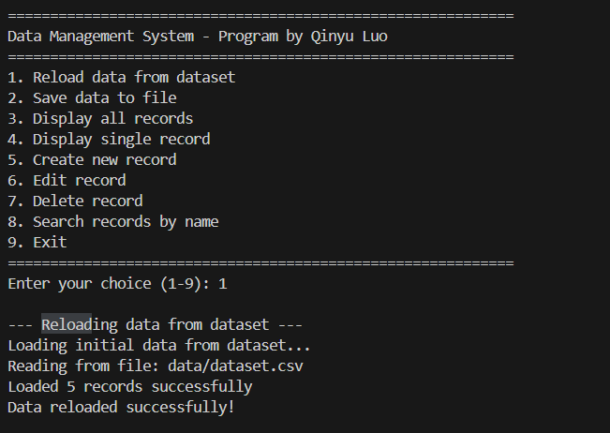
The reload feature successfully replaces in-memory data by re-reading the original dataset file.
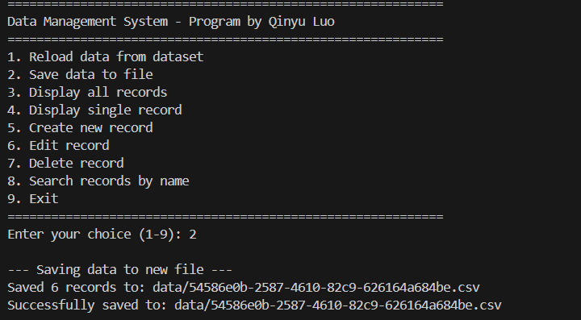
The program generates a unique UUID filename and saves the current records to a new CSV file.
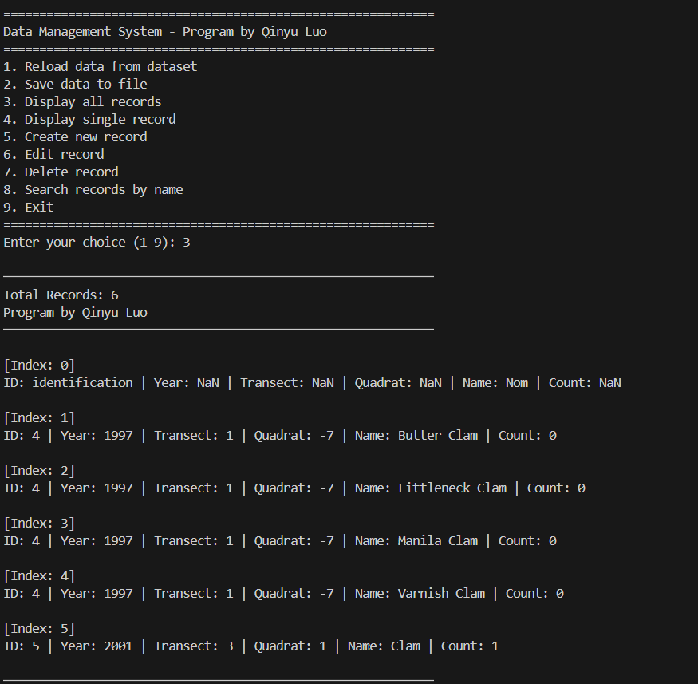
All records are displayed with my name appearing every 10 records as required by the assignment.
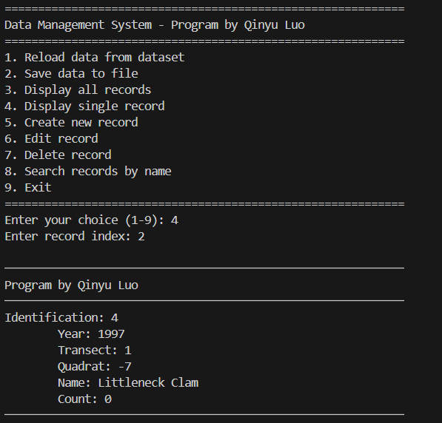
The program retrieves and displays detailed information for a single record selected by index.
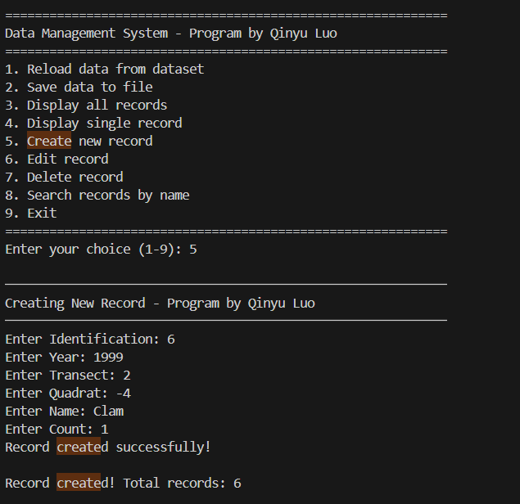
A new record is successfully created with user input and added to the in-memory data structure.
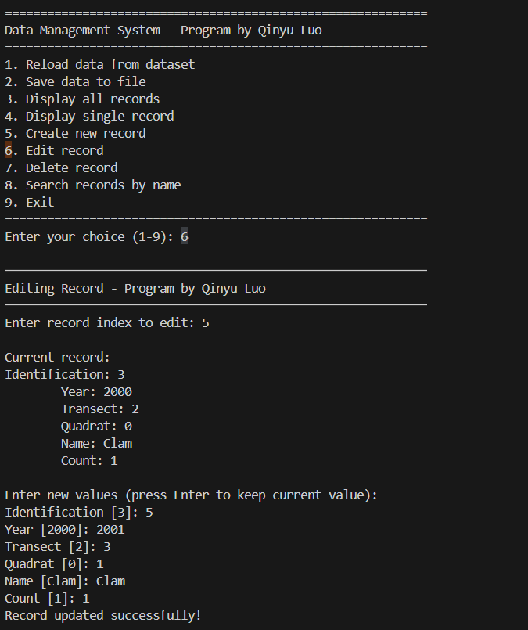
The program allows editing of an existing record by index, showing current values and accepting new input.
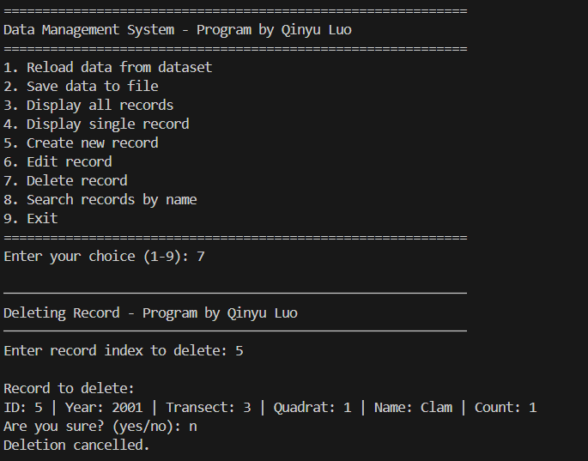
The selected record is successfully removed from the data structure after user confirmation.
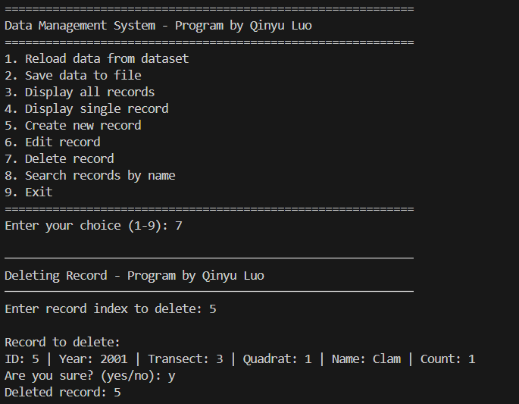

Unit Testing Demonstration via Screen Shots

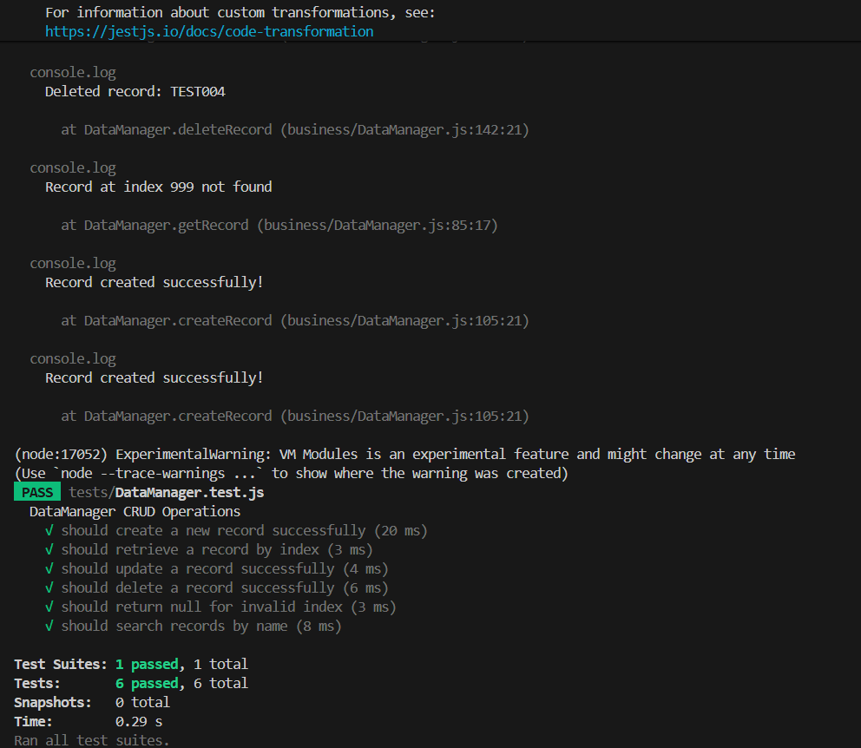
All unit tests pass successfully using the Jest testing framework, verifying CRUD operations on the DataManager class.
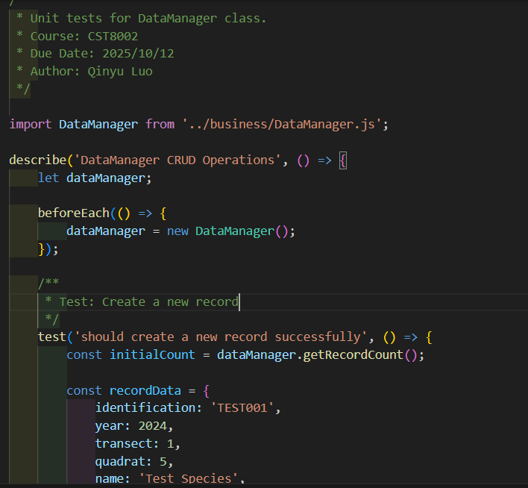
This screenshot shows the unit test code with assertions that validate the create record functionality.

